Test Results Report
Table of Contents:
- Introduction
- Test Results Overview
- Test Results Analysis
- Logs and Outputs

Contributor
İpek Atak

- Introduction
This report documents the results for the four acceptance tests conducted for the Planeta web application before the demo. The tests are based on the test cases defined in the Quality Assurance document: TC-01 (Interface-based Registration), TC-02 (Logic Service Scoring), TC-03 (Data Persistence Verification) and TC-04 (Award System Thresholds).
All tests were conducted in a Chrome browser with Firebase services active.
- Test Results Overview
All four acceptance tests passed successfully, no critical issues encountered during the testing.

Test ID | Test Name | Related Use Cases | Result
TC-01 | Interface-based Registration | UC1 | PASS
TC-02 | Logic Service Scoring | UC3 | PASS
TC-03 | Data Persistence Verification | UC3 + UC4 | PASS
TC-04 | Award System Thresholds | UC3 + UC4 | PASS

- TC-01: Interface Based Registration
Test Responsible | İpek Atak
Test Date | 06.04.2026
Test Configuration | Chrome browser, Firebase Auth and Firestore services active
Test Inputs | Email: tc1@etu.edu.tr / Username: TC1 / Password: tc123456
Result | PASS
Issues | None

- TC-02: Logic Service Scoring
Test Responsible | İpek Atak
Test Date | 06.04.2026
Test Configuration | Chrome browser, Firebase Auth and Firestore services active
Test Inputs | Email: tc1@etu.edu.tr / Password: tc123456 / All questions answered with the highest option
Result | PASS
Issues | None

- TC-03: Data Persistence Verification
Test Responsible | İpek Atak
Test Date | 06.04.2026
Test Configuration | Chrome browser, Firebase Auth and Firestore services active
Test Inputs | Email: tc1@etu.edu.tr / Password: tc123456 / All questions answered with the highest option
Result | PASS
Issues | None

- TC-04: Award System Thresholds
Test Responsible | İpek Atak
Test Date | 06.04.2026
Test Configuration | Chrome browser, Firebase Auth and Firestore services active
Test Inputs | Email: tc1@etu.edu.tr / Password: tc123456 / All questions answered with the highest option
Result | PASS
Issues | None

- Test Results Analysis
All four acceptance tests passed successfully. No failures or critical issues were encountered during testing.

TC-01 confirmed that the registration flow works completely. The user document was created in Firestore immediately after registration and the application redirected to the Home Screen as expected.
TC-02 confirmed that the scoring engine computes the survey result correctly. For this test, all questions were answered with the highest option possible and the application returned a score of 100/100 with the appropriate feedback message: “Excellent – You’re an environmental champion!”

TC-03 confirmed that the submitted survey data is correctly presisted and immediately visible in the history screen without a manual refresh. The survey entry appeared under “Previous Surveys” with the correct date and score.
TC-04 confirmed that the award system works correctly. After submitting a survey with a score of 100, the “Beginner” badge was granted and the “Lifetime Score” was updated to 100, both visible on the “My Achievements” screen.
Overall, the application behaved as expected across all tested scenarios. The results indicate that the core functionality of the project is stable and ready for the demo.
- Logs and Outputs
The following screenshots were captured during acceptance testing as evidence of the test results.
Figure 1 - Firebase Authentication Console (TC-01) Shows the registered user tc1@etu.edu.tr successfully created in Firebase Authentication on April 6, 2026.
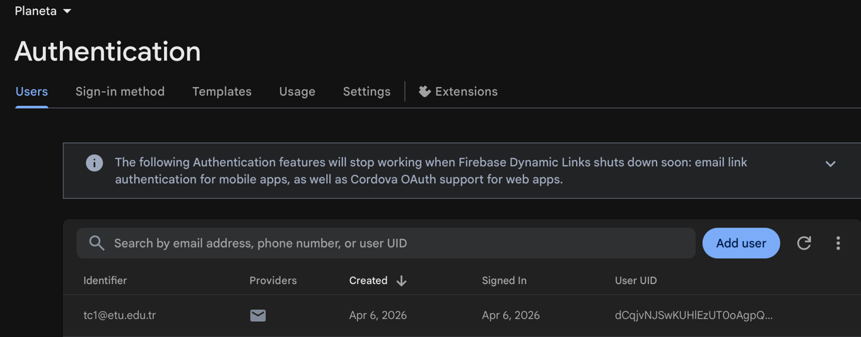

Figure 2 - Survey Complete Screen (TC-02) Shows the application returning a score of 100.0/100 with the feedback message "Excellent –You're an environmental champion!" after all questions were answered with the highest option.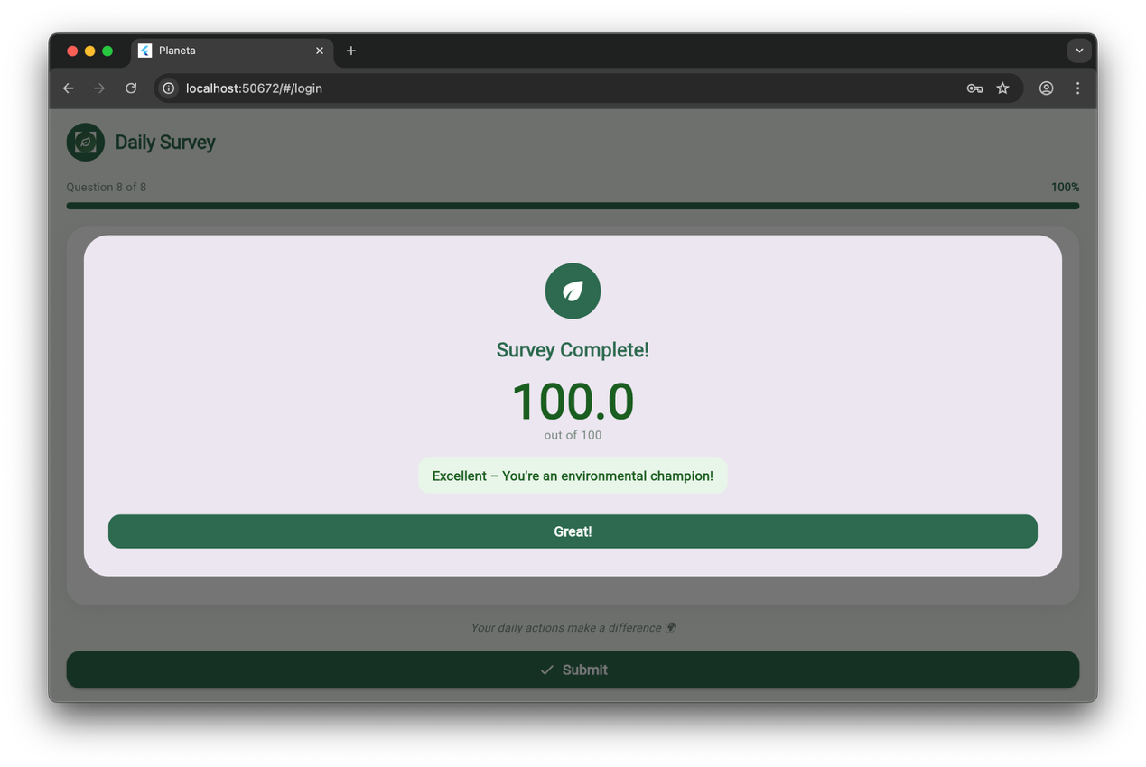
Figure 3 - My Achievements Screen (TC-03 + TC-04) Shows the submitted survey entry (April 06, 2026, Score: 100) visible under Previous Surveys, and the Beginner badge granted with a Lifetime score of 100.
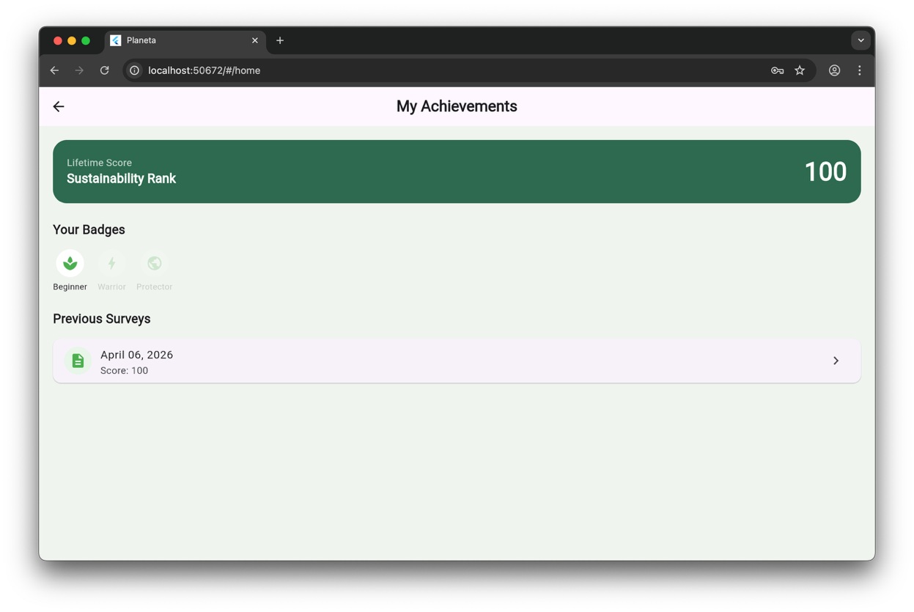
Figure 4 - Survey Analysis Detail (TC-03) Shows the detailed view of the submitted survey with all answers and the score 100/100.
